Here are information from [https://www.nationaljewish.org/education/health-information/exercise-and-weight/exercise-at-home/](https://www.nationaljewish.org/education/health-information/exercise-and-weight/exercise-at-home/step-ups)

**Exercise at home**

Exercise and staying active are an important part of rehabilitation for chronic disease. img-stock-HorizAbduction2.jpgBelow are some exercises you can do at home, but be sure to discuss any plans to begin exercising with your doctor.

If you experience any pain with these exercises, please do not continue with the movement and contact your provider.

**Posture Exercise---Better posture means better breathing and movement.**

**Strength Exercise--** **Strength exercises can improve your breathing, strength and ability to move.**

**1.Axial Extension**

**How this helps:** It lengthens your spine, which improves posture, and increases comfort, mobility and range of motion. Many of us have a forward head posture. We get this from the type of recreation and work activities we do every day. This posture changes our patterns of movement and our breathing efficiency.

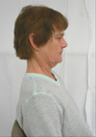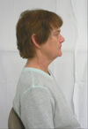

**How to do it:** Look straight forward.  Tuck your chin to align your ears over your shoulders. This will create a double chin if performed correctly. Hold this position for 10 seconds.

Relax and return to the starting position. Repeat 5 to 10 times.

**2.Dowel Exercise**

**How this helps:** It strengthens your arm muscles and requires you to use your abdominal muscles and diaphragm for breathing.  This exercise will decrease your feeling of breathlessness by strengthening your breathing muscles.

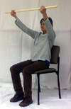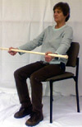

**How to do it:** Sit in a chair with your arms slightly bent. Raise and lower a dowel rod*. Inhale for one count (one second) while lifting the dowel; exhale for two counts while lowering the dowel. At this rate, you will lift and lower the dowel 20 times per minute. Use a clock with a second hand to monitor the rate.

Do this exercise for two minutes and then increase by 15 to 30 seconds every two to three sessions. Work up to 15 minutes, then add a ½ pound weight** to each wrist.

* A 3/4 inch dowel rod can be purchased at a local hardware store or you can cut off the handle of an old broom.

**Wrist weights can be purchased at sporting goods stores or department stores such as Target or Wal-Mart.

*This information has been approved by*[*Kimberly Sack, MS, PT*](https://www.nationaljewish.org/doctors-departments/kimberly-sack)*(May 2012).*

**3. Modified Knee Bends**

**How this helps:** It improves and maintains strength in your hips and knees.

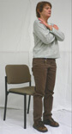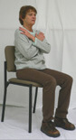

**How to do it:** Use a dining room or kitchen chair for this exercise. With a straight back, and your arms crossed over your chest, tighten your stomach muscles and lean slightly forward as you stand up. Return to sitting and repeat 10 times. Work up to a total of 20 repetitions. Blow air out as you stand up and breathe in as you sit down.

If you can't do this exercise with your arms crossed over your chest, start by reaching forward and out as you stand. As your legs get stronger, cross your arms over your chest to increase the challenge.

*This information has been approved by*[*Kimberly Sack, MS, PT*](https://www.nationaljewish.org/doctors-departments/kimberly-sack)*(May 2012).*

**4. Shoulder Blade Squeeze**

**How this helps:** It opens your chest muscles and helps improve posture.

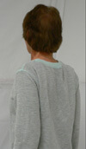

**How to do it:** Stand straight and tall. Pull your shoulder blades back and slightly downward to bring your elbows back and inward.  Return to the starting position. Repeat 10 times.

*This information has been approved by*[*Kimberly Sack, MS, PT*](https://www.nationaljewish.org/doctors-departments/kimberly-sack)*(May 2012).*

**5. Shoulder Horizontal Abduction**

**How this helps:** It strengthens your arms and shoulders.

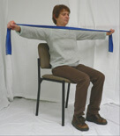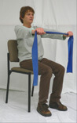

**How to do it:** Use a resistance band or small weight. Reach forward to place your hands directly in front of you at shoulder height. Keep your palms down. Reach out to the sides of your body with both hands at the same time. Hold for a count of three to five seconds and repeat 10 times.

Increase by three repetitions each week until you can easily do 20 repetitions.You are now ready to progress to the next level of resistance band. You will return to doing 10 repetitions with the higher resistive band.

*This information has been approved by*[*Kimberly Sack, MS, PT*](https://www.nationaljewish.org/doctors-departments/kimberly-sack)*(May 2012).*

**6.Step Ups**

**How this helps:** It improves and maintains strength in your legs and your balance.

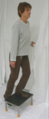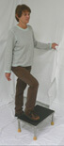

**How to do it:**Find a platform that is eight to nine inches high. Stand next to it while using a  handrail or counter for support. Slowly step up onto the platform with your right foot and follow with your left foot. Lower yourself back to the starting point and repeat 10 times, leading with the right foot. Repeat for another set of 10 repetitions leading with the left foot.  Keep breathing, don’t hold your breath while exercising.

*This information has been approved by*[*Kimberly Sack, MS, PT*](https://www.nationaljewish.org/doctors-departments/kimberly-sack)*(May 2012).*